**2017 Membership Drive**

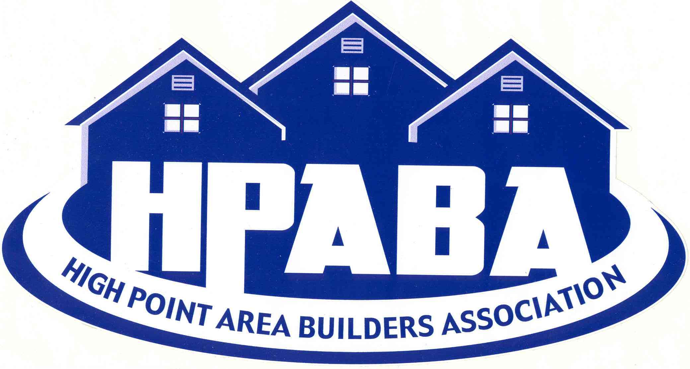

**Join us May 9th 6:00-8:00 pm for our spring membership drive at Dodge Ilderton, 701 S. Main St., High Point.**

Food will be provided by BBQ Joe’s. Water, soft drinks, and beer will be complimentary.

There will be a live band for entertainment.

Our speaker for the evening is City Councilman and candidate for High Point Mayor, Jim Davis.

Bring cash for out 50/50 raffle!

[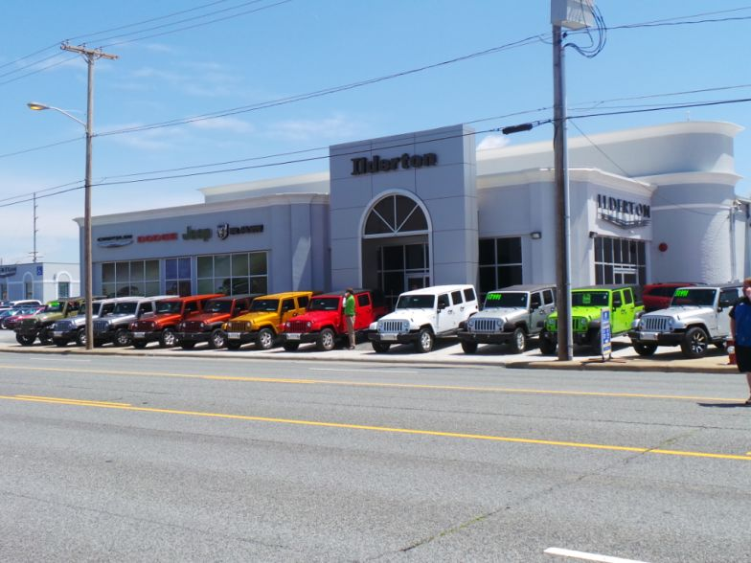](https://www.google.com/url?sa=i&rct=j&q=&esrc=s&source=images&cd=&cad=rja&uact=8&ved=0ahUKEwiF2_KF97XTAhWENSYKHT9lA_gQjRwIBw&url=https://www.cars.com/dealers/184281/ilderton-dodge-chrysler-jeep-ram/&psig=AFQjCNFu9ZRLJ9PHQBbZQkz40FPDelLVtQ&ust=1492877030903546)

**Members**: The month of May is triple spikes! There will be a $25 gift card for the member who brings the most guests and a $50 gift card for most conversions in May.

[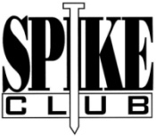](http://www.google.com/url?sa=i&rct=j&q=&esrc=s&source=images&cd=&cad=rja&uact=8&ved=0ahUKEwi8_Yiu-LXTAhUIwiYKHWmRDfYQjRwIBw&url=http://www.nihba.com/members/spike-club.html&psig=AFQjCNFrAtz8MBC55OLe_08E9xz9uZJ43g&ust=1492877533246591)

